* Cache/Buffer is a temporary memory that hold data for while.. and also reuses its data.
* In Client-Server app , the buffer at client side holds the server supplied data and uses it accorss the multiple same requests. Therefore network round trips between Client and web-app will be reduced.

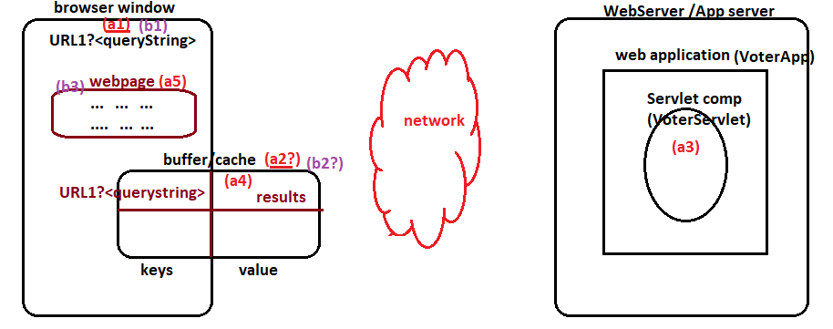

By default every web comp/servlet comp generated output will be placed in the browser cache against given url and query string . But we can instruct browser not to enable caching for certain servlet comp generated output. For that we need to use response header “cache-control” or “pragma” as shown below.

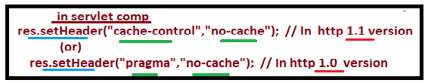

* The servlet comps that are displaying non-commerce data like google-search results, gmail home page and etc.. can keep their results in the cache of browser. By default it is ON.
* The servlet comps that are displaying commerce data like LIVE game scores, stock market share values and etc.. should not keep results /content in the cache of browser.